Structural and Organizational Concepts

Critical Data Elements

Metadata from these sources…

Business Semantics Glossary

Reference Data Management

Policy, Rule, and Issue Management

Data Sharing Agreements

Model Risk Governance

Data Dictionaries

Asset Types

… are represented as these asset types in the Collibra Platform

Business Terms and Acronyms

Code Values and Code Sets

Policies, Rules, Data Issues

Data Usage and Data Sharing Agreements

Data Sets

Schemas, Tables, Columns, and Source Systems

|  |  |
| --- | --- |
| Metadata | Asset Type |
| Business Semantics Glossary | Reference Data Management |
| Policy, Rule, and Issue Management | Data Sharing Agreements |
| Model Risk Governance | Data Dictionaries |
| Business Terms and Acronyms | Code Values and Code Sets |
| Policies, Rules, Data Issues | Data Usage and Data Sharing Agreements |
| Data Sets | Schemas, Tables, Columns, and Source Systems |

Asset

Definition

The fundamental building block for which you want to capture information in the Collibra Platform

Details

An asset belongs to exactly one domain and has a unique “full name” within its domain

An asset is an instance of exactly one asset type

An asset has characteristics (attributes and relations)

Characteristics of Asset

Attributes – Capture information about an asset

Do not involve other assets

Relations – They add details to assets

Used to create a relation between 2 assets

An asset can have multiple occurrences of the same relation type

Attributes have an attribute kind, which formally defines the class of information that is contained in an attribute

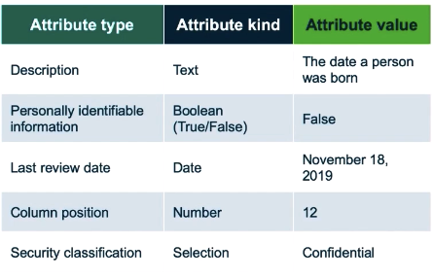

Relations defines how 2 assets are related to each other

Is an instance of exactly one Relation Type

Relation Types specify both directions of the relation

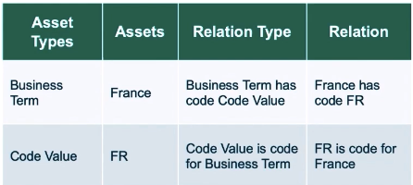

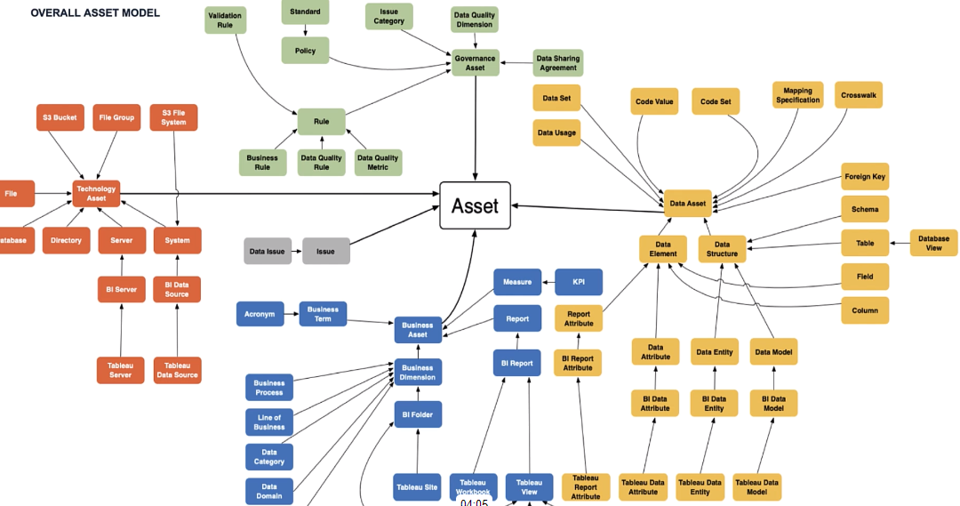

Domains and Domain Types

Domain

Definition

A logical grouping of assets according to their function, project, or knowledge area

Details

Are of a specific domain type

Belong to exactly one community

Has a unique name within its community

Domain Type

Definition

Domain types formally define which type of assets can be created in the domain

Details

In a domain of the type Glossary, you can create Business Terms and Acronym assets

In a domain type of Physical Data Dictionary, you can create Schema, Table, and Column assets

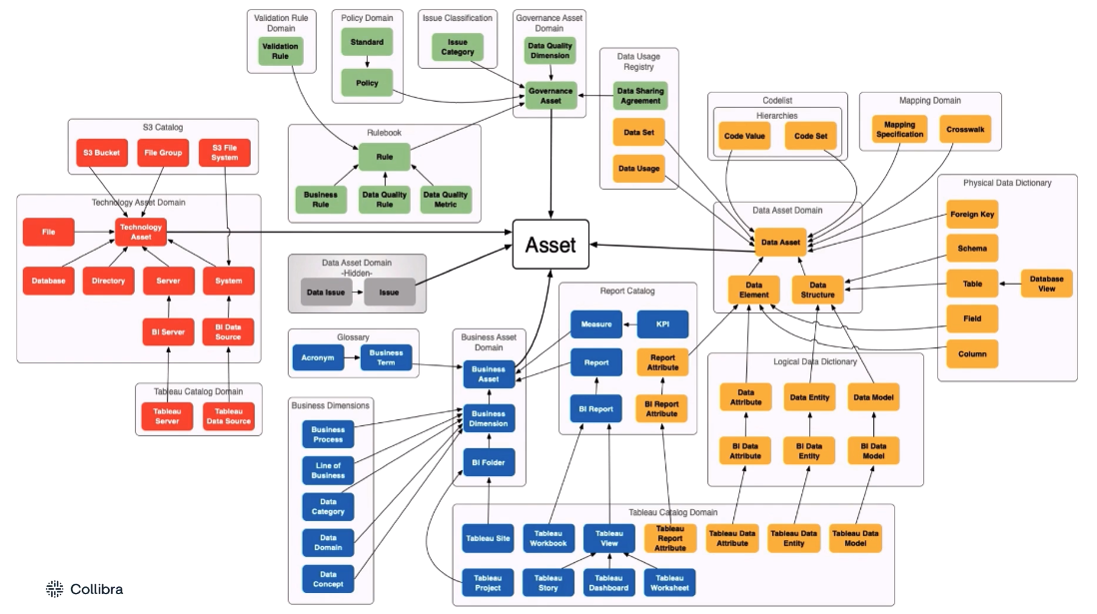

Community

Definition

Communities represent different groups of people with responsibility over specific assets

Details

A community is a grouping of sub-communities and/or Dommains

A sub-community is a community that has a parent community

A root community (top-level) is a community without a parent community

Communities & sub-communities must have a globally unique name

Business Glossary

Go to system to cover business terms

Why do we need a business glossary?

Governs your business terms, processes, reports, and KPIs

Includes associated definitions and relationships

Provides a procedure for establishing rules, policies, codes, terms and definitions

Fosters a common language

Allows key decision makers to understand their data from a business perspective

Assigns responsibilities to determine ownership over assets

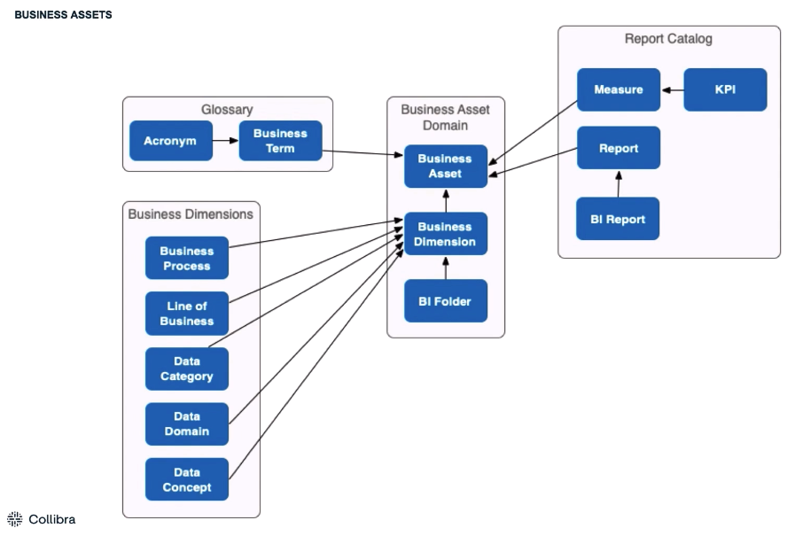

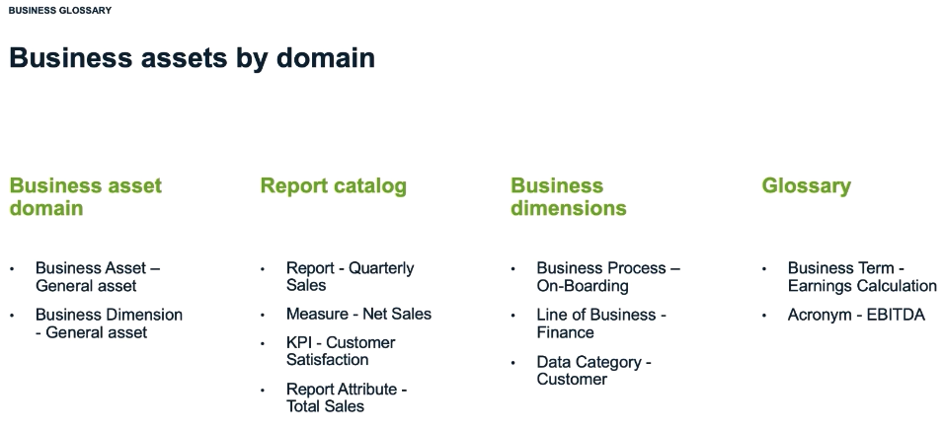

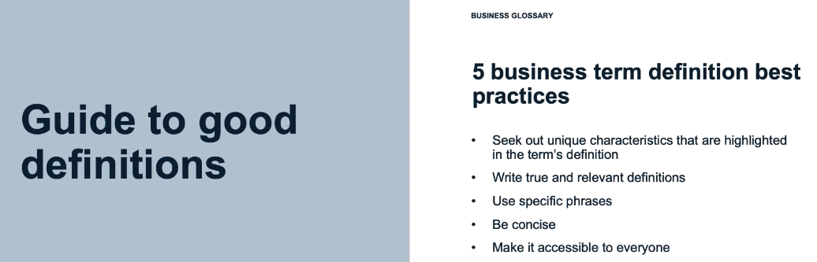

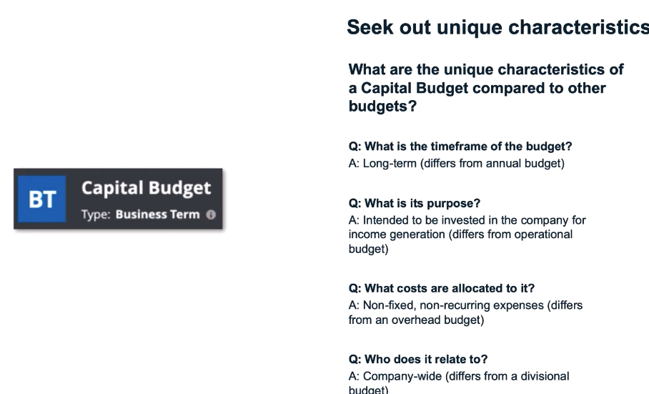

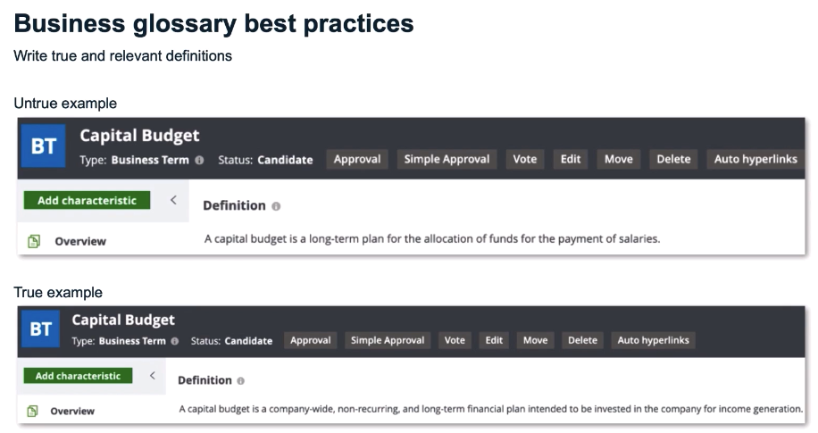

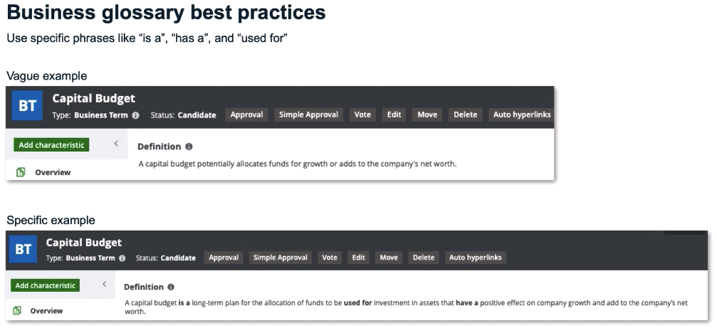

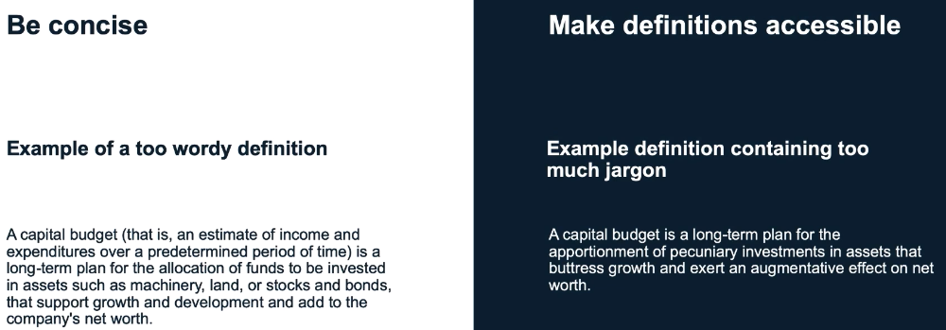

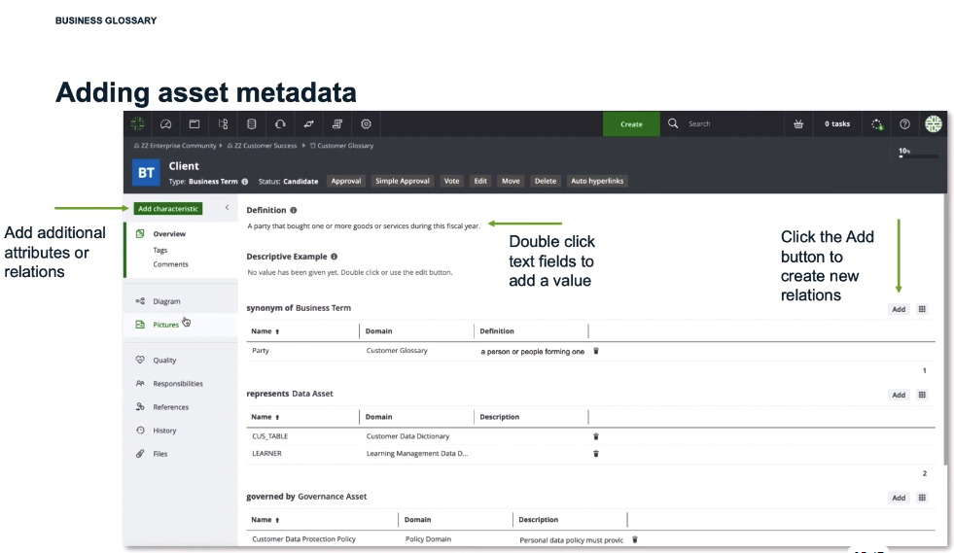

Data Dictionary

Data Assets by domain

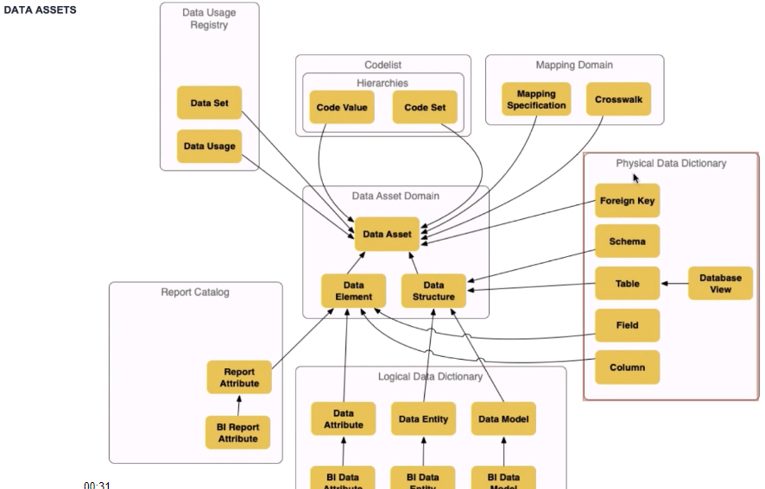

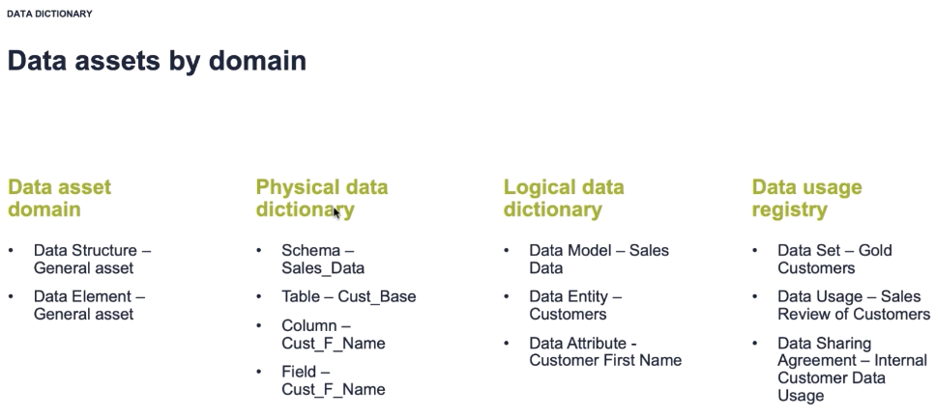

Data Dictionary Assets

Physical vs. logical layers

Physical layer is taking the implementation system for technical stakeholder communication into account

Logical layer is independent of any technology for non-technical stakeholder communication

|  |  |
| --- | --- |
| **Physical Data Assets** | **Schema** |
| Table | Column / Field |
| Logical Data Assets | Data Model |
| Data Structure | Data Element |

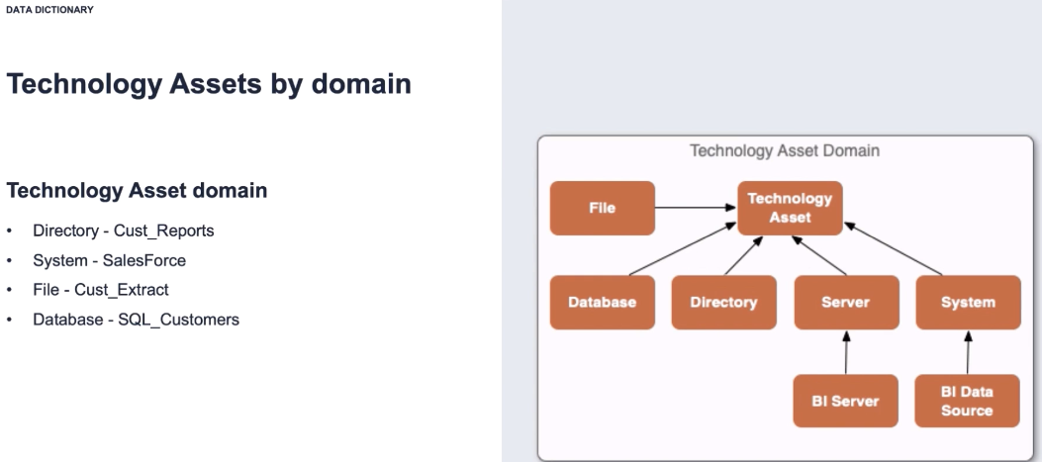

Asset Views

Import assets to existing resources

Spelling needs to be accurate

Assets/Domains/Communities are case-sensitive

Ensure that there are no spaces after the name in Collibra Platform nor the spreadsheet values

You can see all the resources which will be created using a Test Import. Check for accuracy.

Exporting

Creates a template to guide users

Select to export fields which are required for re-importing

Column names will auto-map during re-import

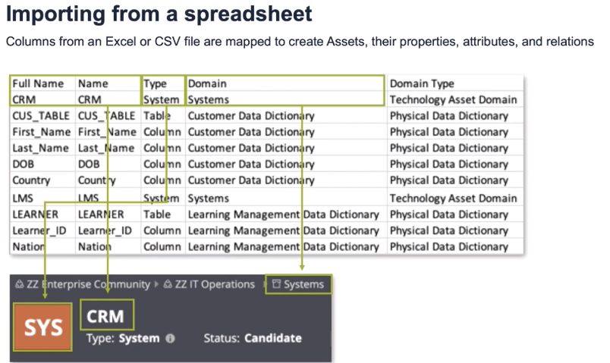

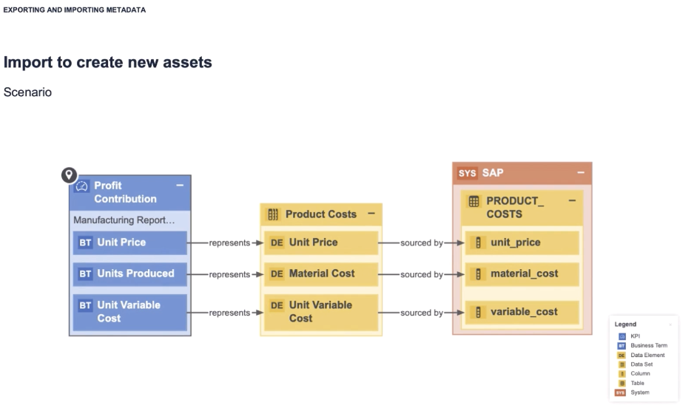

Governance Assets

Policy Manager and Validation Rules

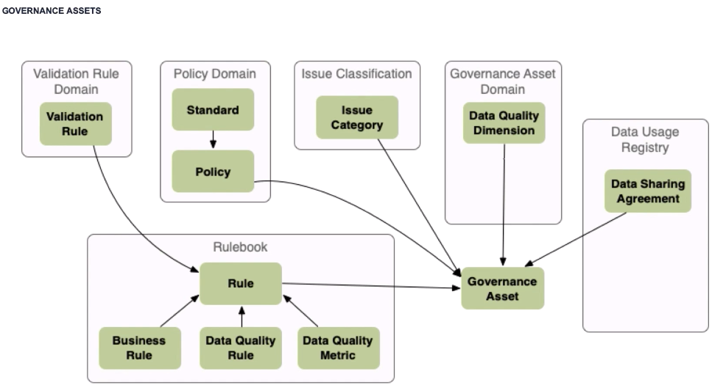

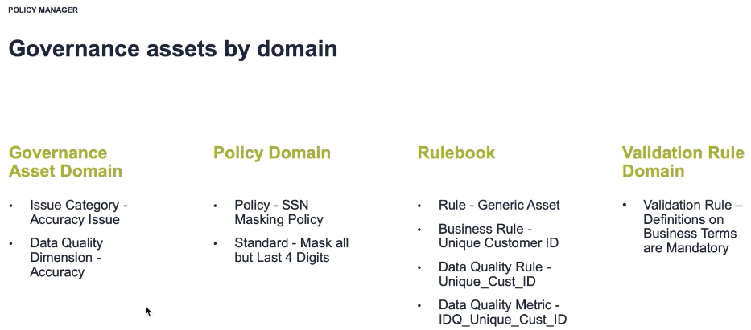

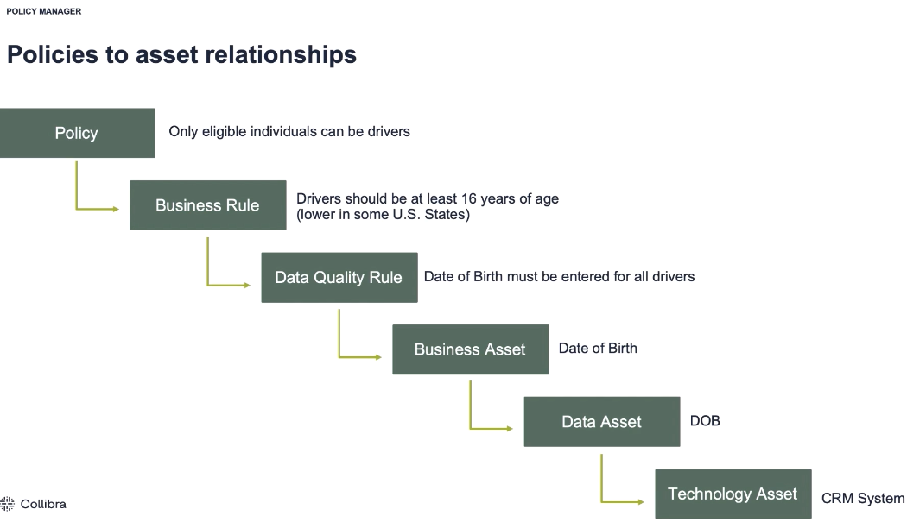

Validation Rules

Definition

Validation rules are a special asset type

They verify whether assets meet certain criteria

They have a special attribute called **Validation Script** that evaluates assets of the types to which the Validation Rule is assigned

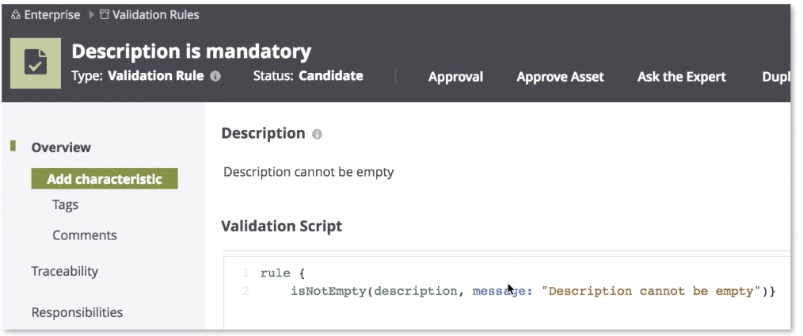

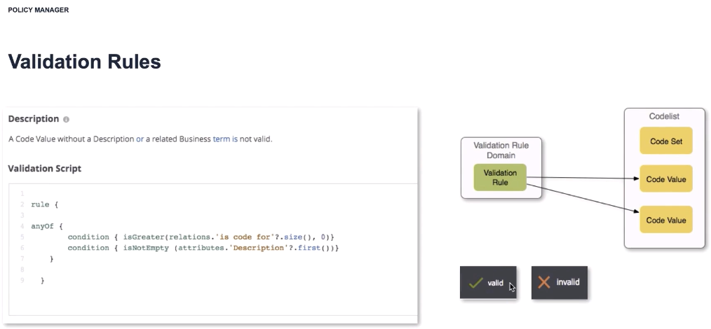

Asset Assignment – available only to system administrator

Asset types and their assignments

Assignments Determine

Possible attributes and relations (characteristics)

In which domain types the asset type may be created

Status options

Articulation score conditions

Data quality rules

Validation rules

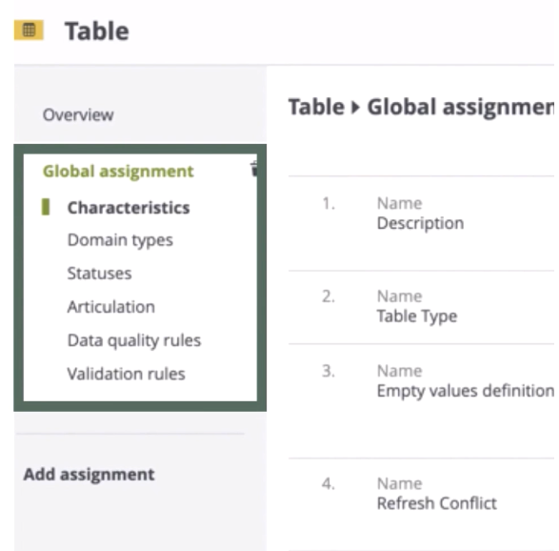

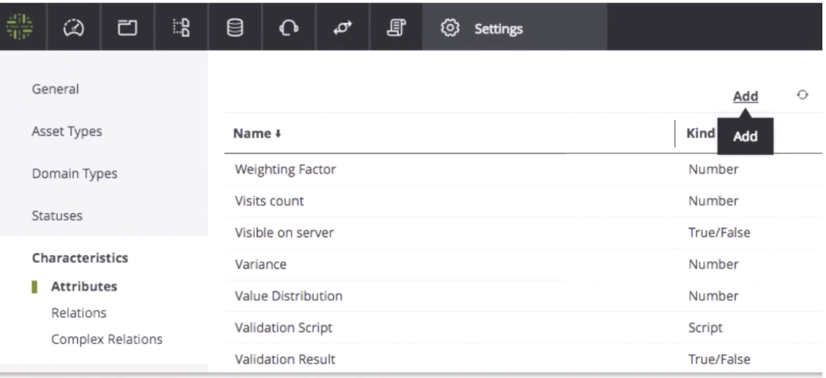

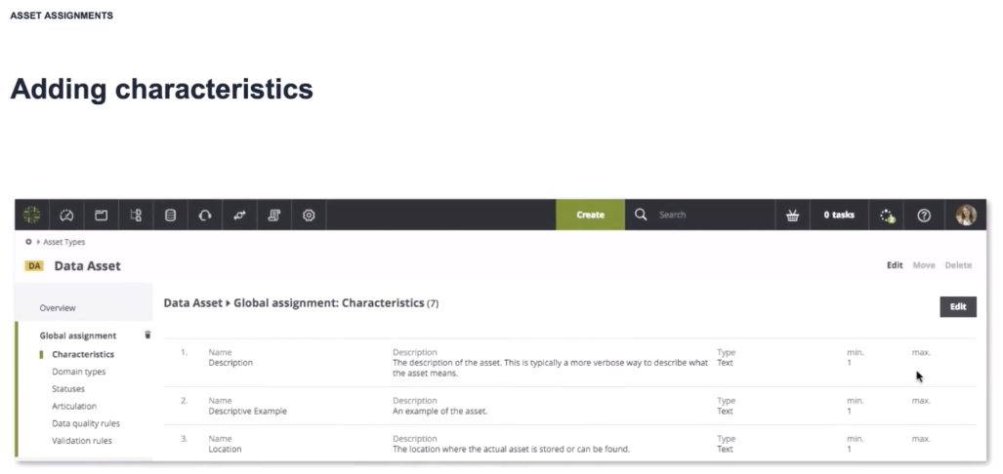

Domain Types

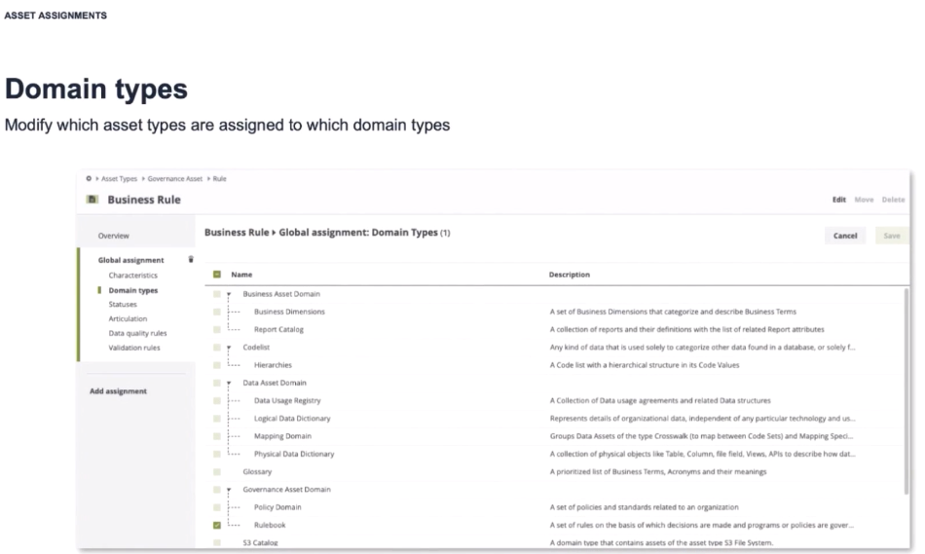

Statuses

Definition

A condition an asset can be in for a given period of time during its lifecycle

Articulation Scores

Definition

The level of completeness of an asset

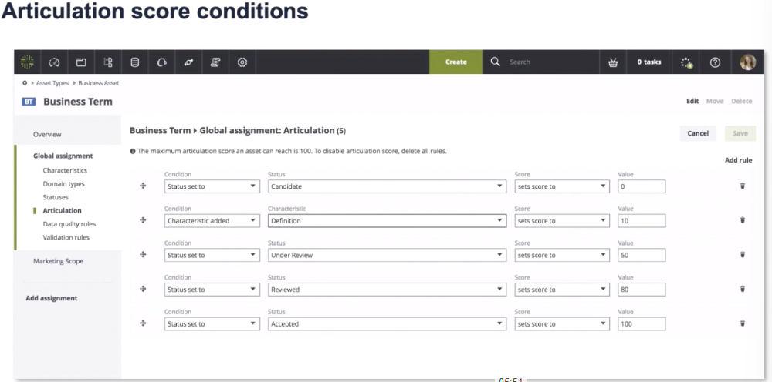

Scopes

Definition

A scope is a selection of domains or communities

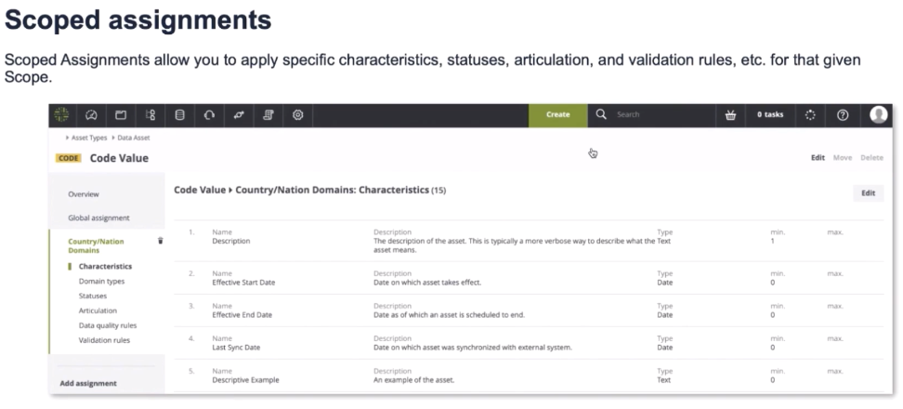

Traceability

Diagram View

Definition

Query that determines which nodes and edges are displayed and how

Found in an Asset’s Diagram Page

Diagram Views are used to display the same relation types for any asset

Note: The diagram displays the configured and existing relations. If the asset does not hae the relation, you will not see any change in the diagram

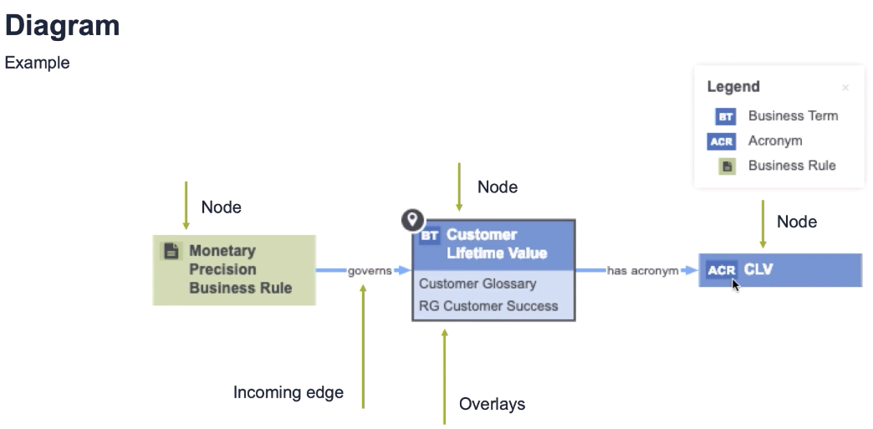

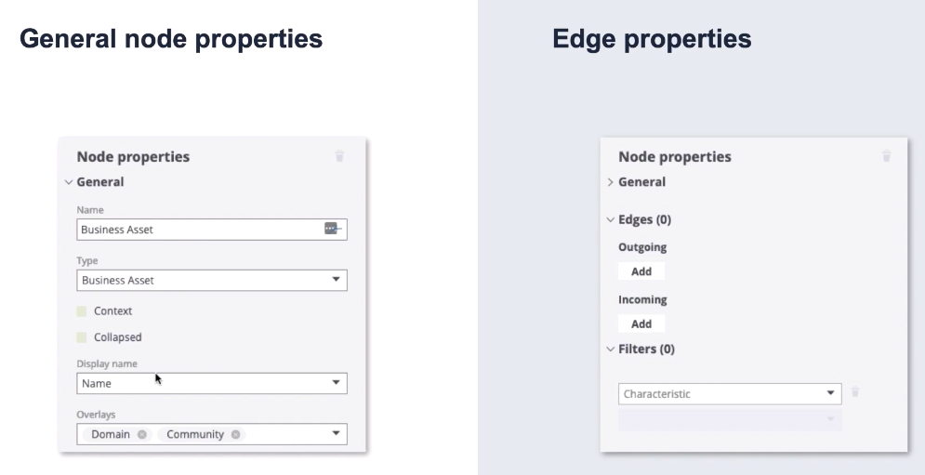

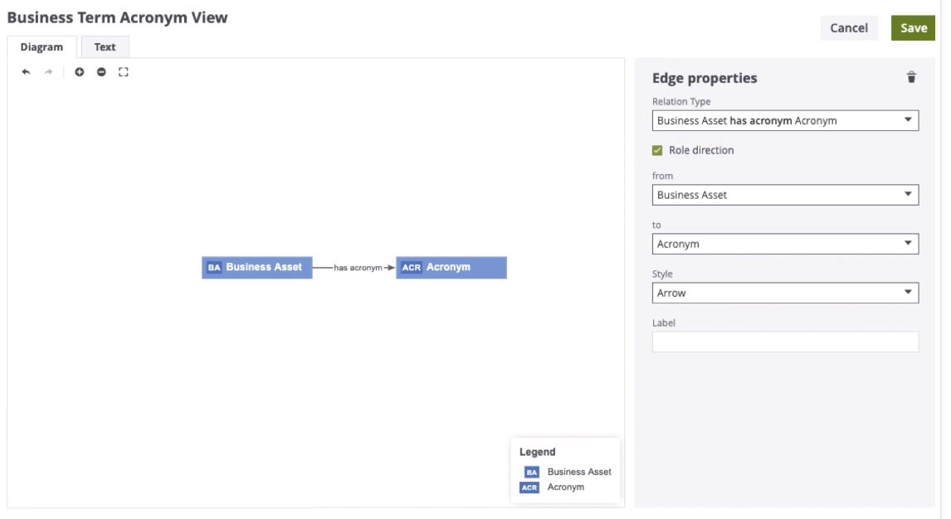

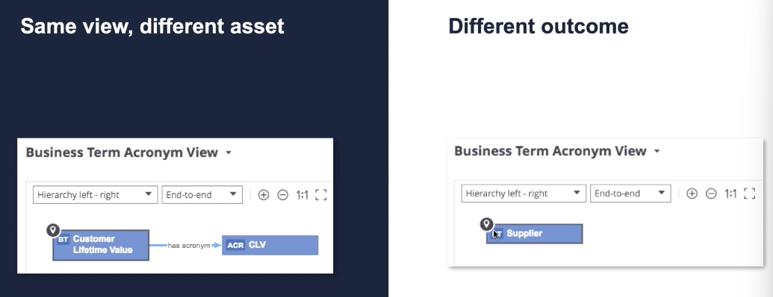

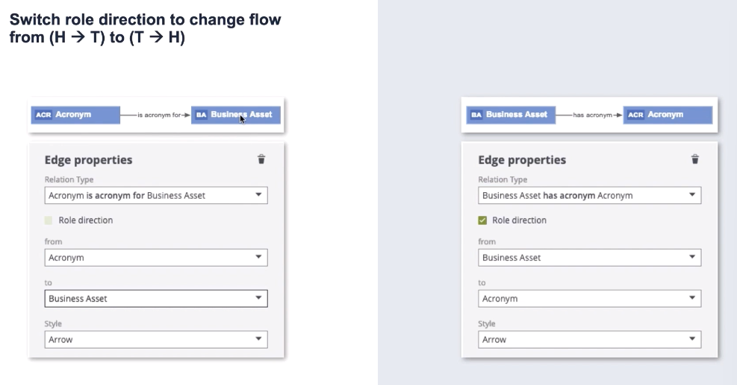

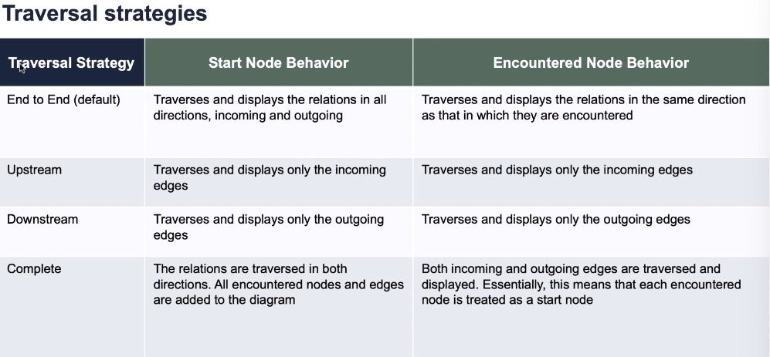

Data Helpdesk

Identify and resolve data issues quickly

Help data users quickly identify and resolve issues

Escalate issues to the right people based on their roles and responsibilities

Create a culture of confidence with improved visibility into issues resolution

Can integrate with IT ticketing systems

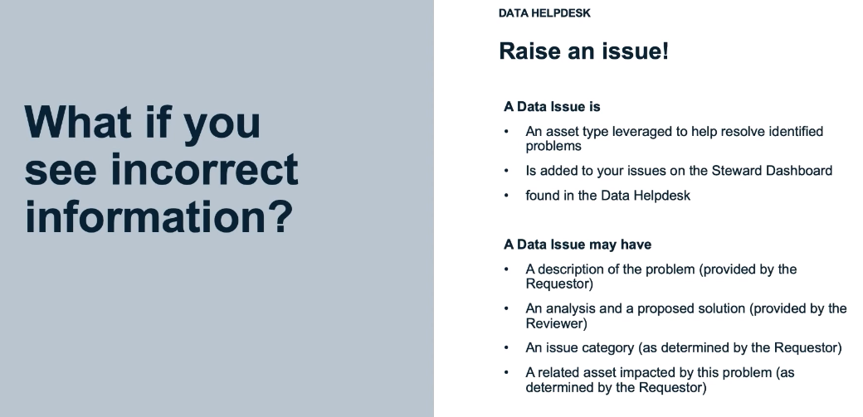

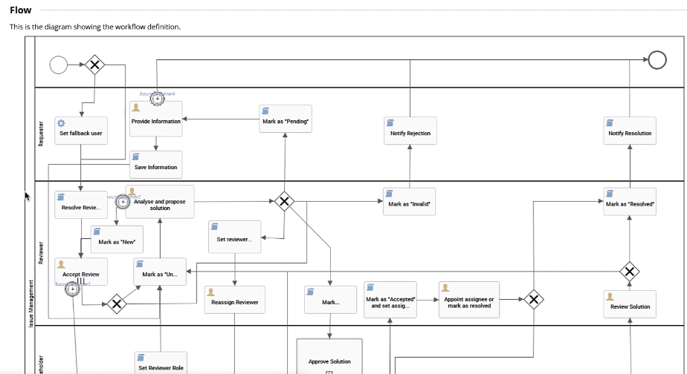

Stewardship

Administrators manage their stewards

Data stewards monitor and maintain their tasks

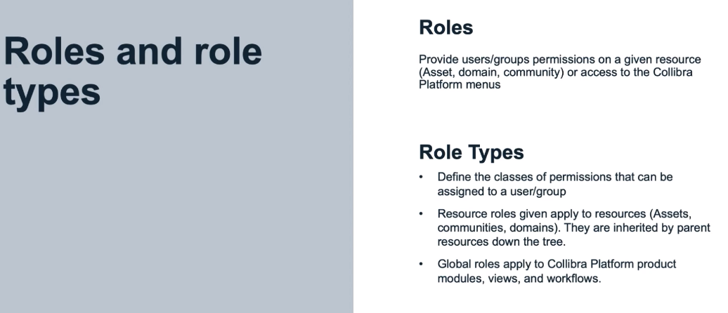

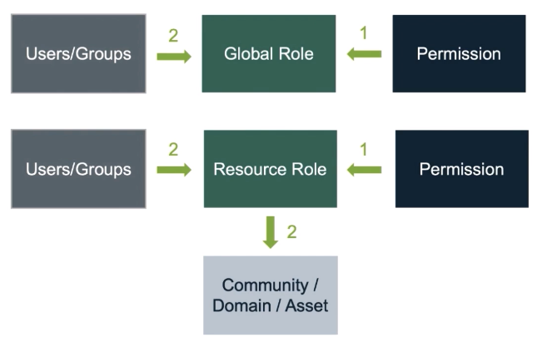

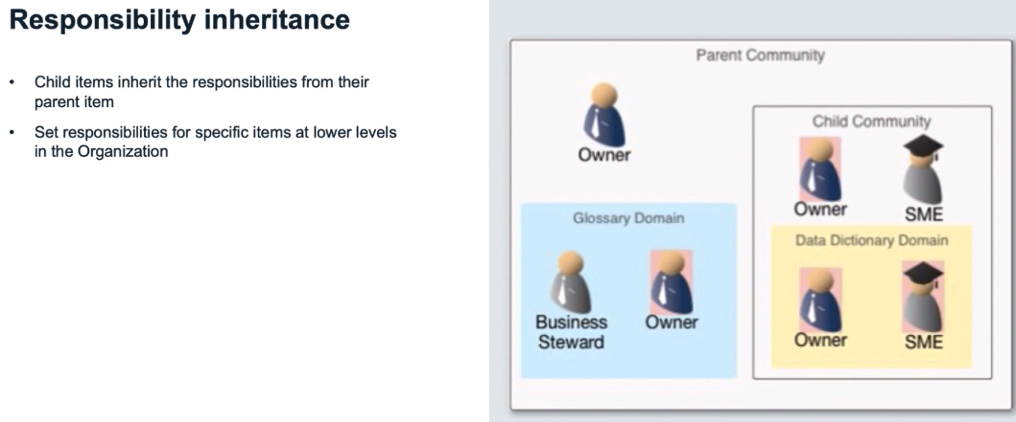

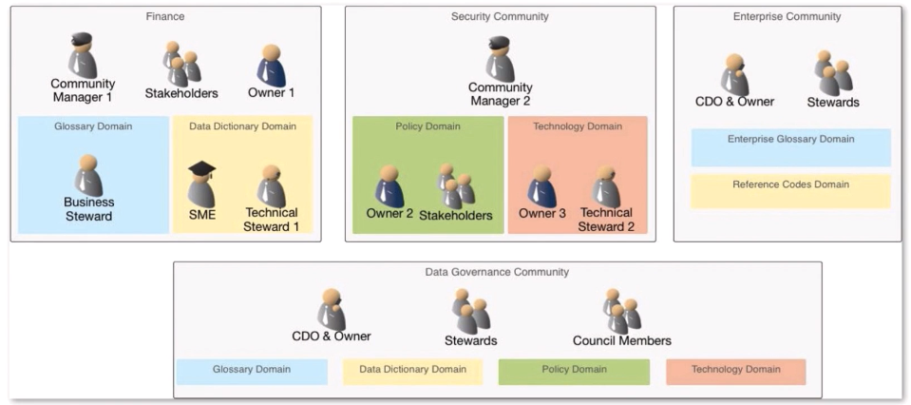

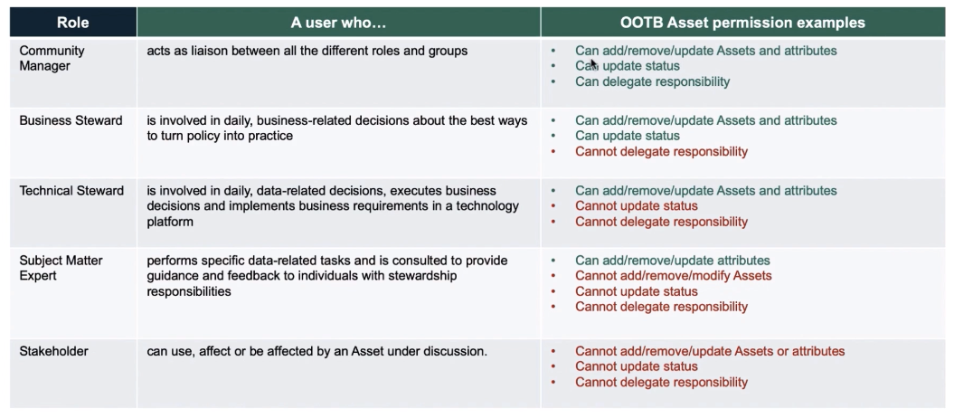

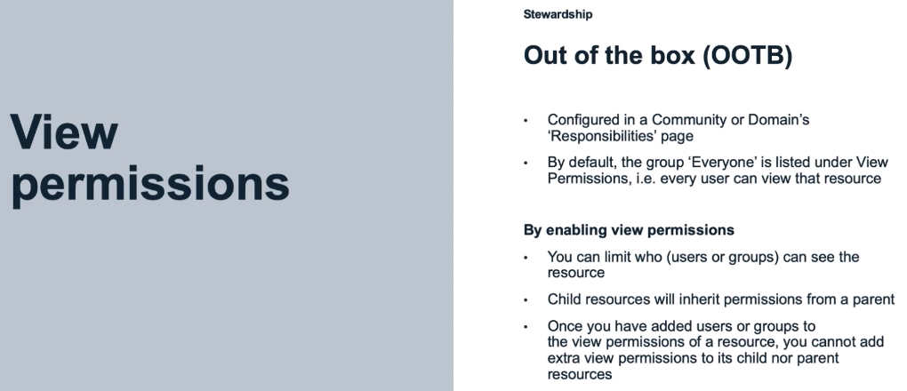

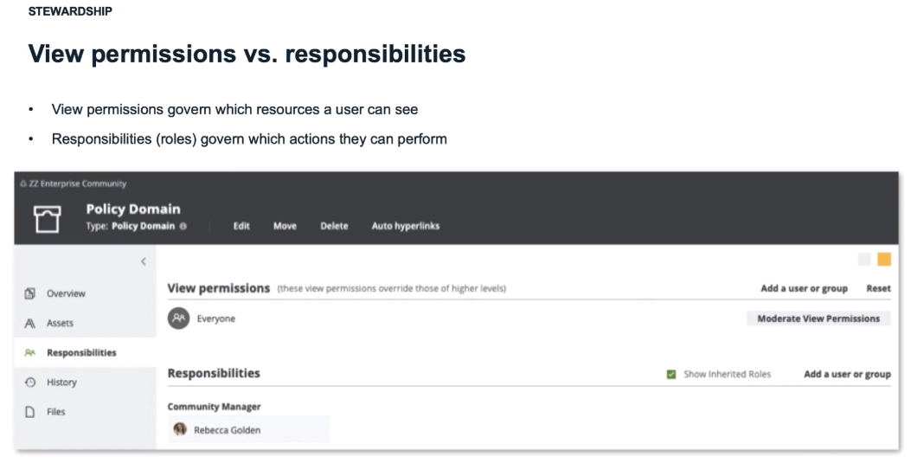

View Permissions govern which resources a user can see

Responsibilities (roles) govern which actions they can perform

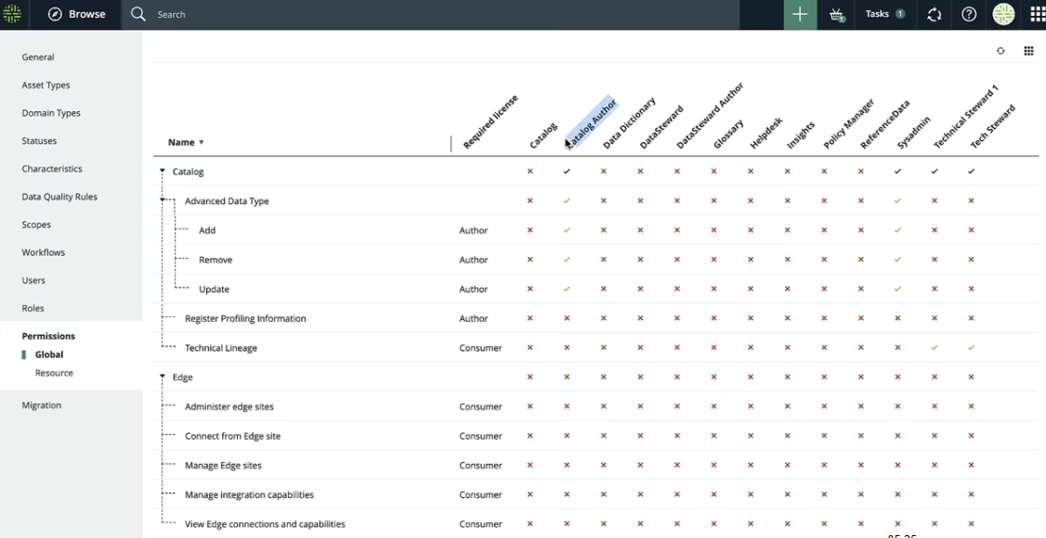

Workflow

Workflow Participation

Definition

Collibra body of Knowledge

A workflow consists of an orchestrated and repeatable pattern of Data Governance execution and monitoring activities. It can be depicted (e.g. using the Business Process Modelling Notation) as a sequence of user-performed tasks and system-performed tasks

Simple definition

A workflow is a series of activities that are necessary in order to complete a task.

